**PROJECT REPORT**

6/30Global Sales Data Analysis

Team Members:

1. TRISHA GHOSH (20BCE11109)
2. ISHA PAWAR (20BCE10297)

# INTRODUCTION

* 1. **Overview**

The Global Sales Data Analytics Project is a comprehensive initiative that focuses on analyzing sales data on a global scale to gain valuable insights and inform business decisions. The project involves collecting and analyzing large volumes of sales data from various sources, including retail stores, e-commerce platforms, distributors, and other relevant channels.

The primary objective of the project is to extract meaningful information from the sales data and generate actionable insights that can drive sales growth, improve operational efficiency, and enhance overall business performance. This involves

utilizing advanced data analytics techniques and tools to identify patterns, trends, and correlations within the data.

Some key components of the Global Sales Data Analytics Project may include:

* + - **Data collection**: Gathering sales data from multiple sources and consolidating it into a centralized database or data warehouse.
    - **Data cleansing and preprocessing:** Cleaning and organizing the data to

remove inconsistencies, errors, and duplicates. This step ensures that the data is accurate and reliable for analysis.

* + - **Data analysis:** Applying various analytical methods, such as statistical analysis, data mining, and machine learning algorithms, to extract insights

from the sales data. This analysis can help identify factors that influence sales performance, customer behavior, market trends, and other valuable

information.

* + - **Visualization and reporting:** Presenting the analyzed data in visual formats, such as charts, graphs, and dashboards, to make it easier for stakeholders to understand and interpret the findings. Reports and presentations are often created to communicate the insights to relevant teams and decision-makers.
    - **Forecasting and predictive analytics:** Utilizing historical sales data and applying predictive modeling techniques to forecast future sales trends, demand patterns, and market opportunities. This enables businesses to anticipate market changes and optimize their sales strategies accordingly.

The Global Sales Data Analytics Project aims to empower organizations with actionable intelligence to optimize their sales operations, enhance customer

experiences, identify growth opportunities, and make informed strategic decisions on a global scale.

# Purpose

The Global Sales Data Analytics Project serves several important purposes and offers numerous benefits to organizations. Here are some of the key uses and achievements that can be obtained through the project:

* + - **Sales Performance Analysis:** The project enables organizations to analyze sales data on a global scale and gain insights into sales performance across different regions, products, channels, or customer segments. This analysis helps identify areas of strength and weakness, allowing businesses to make data-driven

decisions to improve sales strategies and revenue growth.

* + - **Market Trends and Customer Behavior:** By analyzing global sales data, businesses can uncover market trends, customer preferences, and buying patterns. This information can be used to understand customer behavior, identify emerging market trends, and adapt sales and marketing strategies accordingly. Understanding customer preferences helps in targeting the right audience,

improving product offerings, and increasing customer satisfaction.

* + - **Demand Forecasting and Inventory Management:** The project facilitates demand forecasting by leveraging historical sales data and applying predictive

analytics techniques. Accurate demand forecasts enable organizations to optimize inventory levels, minimize stockouts, and reduce excess inventory. This leads to

improved operational efficiency, cost savings, and better customer service.

* + - **Sales Strategy Optimization:** Global sales data analytics provides insights that help in optimizing sales strategies. By analyzing the data, businesses can identify the most effective sales channels, pricing strategies, promotional activities, and product assortments for different regions or customer segments. This optimization ensures that resources are allocated efficiently, resulting in increased sales and

improved profitability.

* + - **Customer Segmentation and Personalization:** Analyzing global sales data allows organizations to segment their customer base effectively. By

understanding customer preferences, purchase history, and behavior, businesses can create targeted marketing campaigns, personalized recommendations, and

tailored offers. This level of customization enhances customer satisfaction, strengthens brand loyalty, and improves customer retention rates.

* **Competitive Analysis:** Global sales data analytics can provide insights into competitor performance, market share, and pricing strategies. By comparing their own sales data with that of competitors, organizations can identify competitive advantages and areas for improvement. This analysis helps in formulating competitive pricing strategies, identifying market gaps, and developing effective sales and marketing tactics to gain a competitive edge.

# LITERATURE SURVEY

* 1. **Existing problem**

There are several existing approaches and techniques that can be employed to solve the Global Sales Data Analysis problem. Here are some common approaches:

* + - **Descriptive Analytics:** Descriptive analytics focuses on summarizing and visualizing sales data to gain a better understanding of historical sales performance. It involves using techniques such as data aggregation, data visualization, and exploratory data analysis to identify trends, patterns, and outliers in the data. Descriptive analytics provides valuable insights into past sales performance and forms the foundation for more advanced analysis.
    - **Predictive Analytics:** Predictive analytics utilizes statistical modeling and

machine learning algorithms to forecast future sales trends and outcomes based on historical sales data. By analyzing historical patterns, predictive analytics

techniques can identify factors that influence sales, such as seasonality, market conditions, marketing campaigns, and customer behavior. This allows

organizations to make informed decisions and develop sales strategies that align with expected future trends.

* + - **Customer Segmentation:** Customer segmentation involves dividing the customer base into distinct groups based on shared characteristics, such as demographics, buying behavior, preferences, or geographic location. By

segmenting customers, businesses can tailor their sales and marketing efforts to target specific groups more effectively. Analyzing sales data alongside customer data helps identify meaningful customer segments and enables personalized

marketing strategies.

* + - **Market Basket Analysis:** Market basket analysis examines the relationships

between products that are frequently purchased together. By analyzing transaction data, businesses can identify associations and patterns in customer purchasing behavior. This information can be used to optimize product placement, cross-

selling, and upselling strategies. Market basket analysis helps identify product associations, enabling businesses to optimize their product offerings and promotions.

* + - **Data Mining and Machine Learning:** Data mining and machine learning

techniques can be applied to sales data to discover hidden patterns, relationships, and insights. These techniques can include clustering algorithms, decision trees, regression analysis, and neural networks. Data mining and machine learning help in identifying factors that contribute to sales performance, identifying customer segments, predicting customer behavior, and optimizing sales strategies.

# Proposed Solution

For our Global Sales Data Analysis Project, We would suggest a comprehensive approach that combines several methods and solutions to derive valuable insights from the sales data. Here is a suggested method:

* + - **Data Collection and Consolidation:** Gather sales data from various sources, such as retail stores, e-commerce platforms, distributors, and other relevant channels. Consolidate the data into a centralized database or data warehouse.
    - **Data Cleansing and Preprocessing:** Cleanse and preprocess the data to remove inconsistencies, errors, duplicates, and missing values. Ensure data quality and

integrity for accurate analysis.

* + - **Descriptive Analytics:** Perform descriptive analytics to summarize and visualize the sales data. Generate reports, charts, and graphs to gain an overview of historical sales performance, identify trends, patterns, and outliers.
    - **Predictive Analytics:** Apply predictive analytics techniques to forecast future sales trends and outcomes. Utilize time series analysis, regression models, or machine learning algorithms to identify factors that influence sales and predict future sales based on historical patterns.
    - **Customer Segmentation:** Segment the customer base based on shared

characteristics, such as demographics, buying behavior, or preferences. Analyze sales data alongside customer data to identify meaningful customer segments and understand their purchasing patterns.

* + - **Market Basket Analysis:** Perform market basket analysis to uncover associations and patterns in customer purchasing behavior. Identify products

frequently purchased together to optimize product placement, cross-selling, and upselling strategies.

* + - **Visualization and Reporting:** Present the analyzed data and insights in visual formats, such as charts, graphs, and dashboards. Create reports and presentations to communicate findings to relevant stakeholders and decision-makers.
    - **Continuous Improvement:** Regularly update and refine the analysis based on new data and feedback. Incorporate feedback and insights gained from the

analysis into sales strategies and decision-making processes to drive continuous improvement.

# THEORITICAL ANALYSIS

* 1. **Block Diagram**

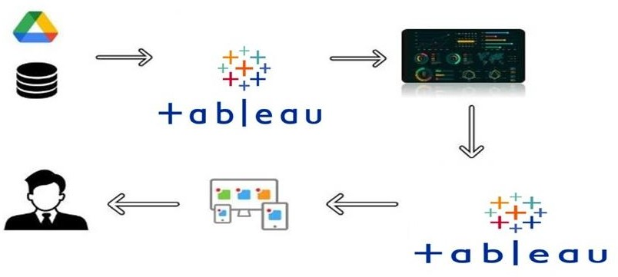

* 1. **Hardware / Software Designing**

Hardware Requirements:

* + - **Computer Systems:** Depending on the volume of data and complexity of analysis, powerful computers or server systems may be required to handle the computational requirements efficiently.
    - **Storage:** Sufficient storage capacity is essential to accommodate the large volumes of sales data collected and processed during the project. This may include hard drives, solid-state drives (SSDs), or cloud-based storage solutions.
    - **Memory (RAM):** The amount of RAM required will depend on the size of the dataset and the complexity of the analysis. A minimum of 8GB RAM is

generally recommended, but higher capacities (16GB or more) are preferable for handling larger datasets.

Software Requirements:

* **Data Management:** MySQL
* **Data Cleansing and Preprocessing:** Microsoft Excel
* **Analytics:** Tableau

## Business Intelligence and Visualization: Tableau

1. **EXPERIMENTAL INVESTIGATIONS**

During the solution development process of a Global Sales Data Analysis Project, several analyses and investigations are typically conducted to extract meaningful insights from

the sales data. Here are the analyses and investigations that had performed:

* **Sales Performance Analysis:** This analysis aims to understand the historical sales performance across different regions, products, channels, or customer segments. It involves examining key sales metrics such as revenue, units sold, average order value, and conversion rates. By comparing performance across various dimensions, trends, patterns, and outliers can be identified, enabling businesses to assess the effectiveness of their sales strategies and make data-driven decisions for improvement.
* **Trend Analysis:** Trend analysis examines the long-term patterns and tendencies in sales data. It involves analyzing sales data over time to identify seasonal

variations, cyclical patterns, or overall sales growth or decline trends. This

analysis helps in forecasting future sales and understanding the impact of external factors on sales performance.

* **Market Analysis:** Market analysis investigates the market dynamics and trends that influence sales. It includes assessing market size, market share, competitor analysis, and identifying emerging market trends. This analysis helps

organizations understand their position in the market, identify growth opportunities, and adapt their sales strategies accordingly.

* **Customer Behavior Analysis:** Customer behavior analysis focuses on understanding customer preferences, buying patterns, and segmentation. It involves examining customer data alongside sales data to identify customer

segments, assess customer loyalty, and analyze customer lifetime value. This analysis helps businesses tailor their sales and marketing strategies to specific customer segments, personalize offerings, and enhance customer experiences.

* **Product Analysis:** Product analysis involves examining sales data to evaluate the performance of individual products or product categories. It includes assessing product popularity, identifying best-selling products, analyzing product

profitability, and identifying underperforming products. This analysis helps organizations optimize their product offerings, identify opportunities for product diversification, and allocate resources effectively.

* **Forecasting and Predictive Analytics:** Forecasting analyzes historical sales data to predict future sales trends and demand patterns. It involves applying time series analysis, regression models, or machine learning algorithms to identify underlying patterns and make accurate sales forecasts. This analysis helps organizations plan inventory, optimize resource allocation, and make informed decisions based on future sales projections.

# FLOWCHART

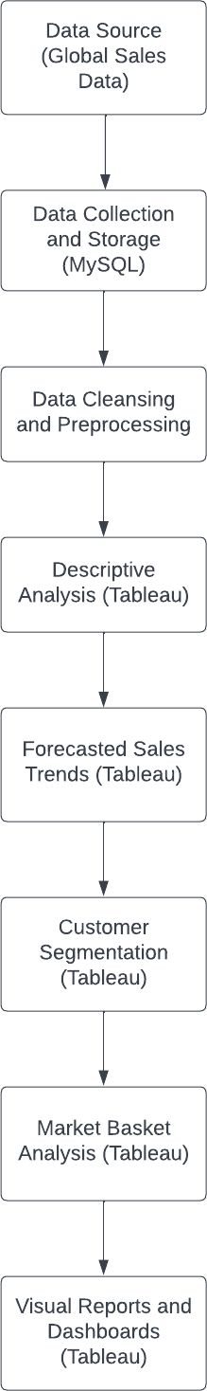

1. **RESULT**

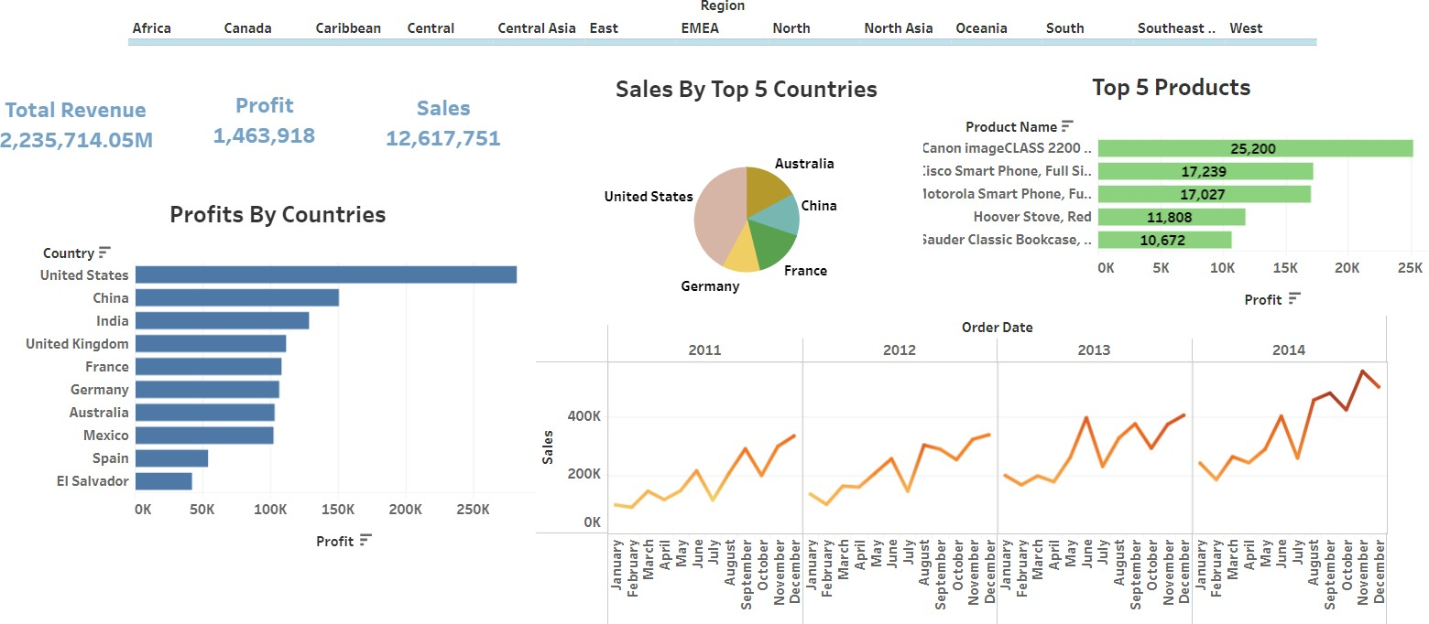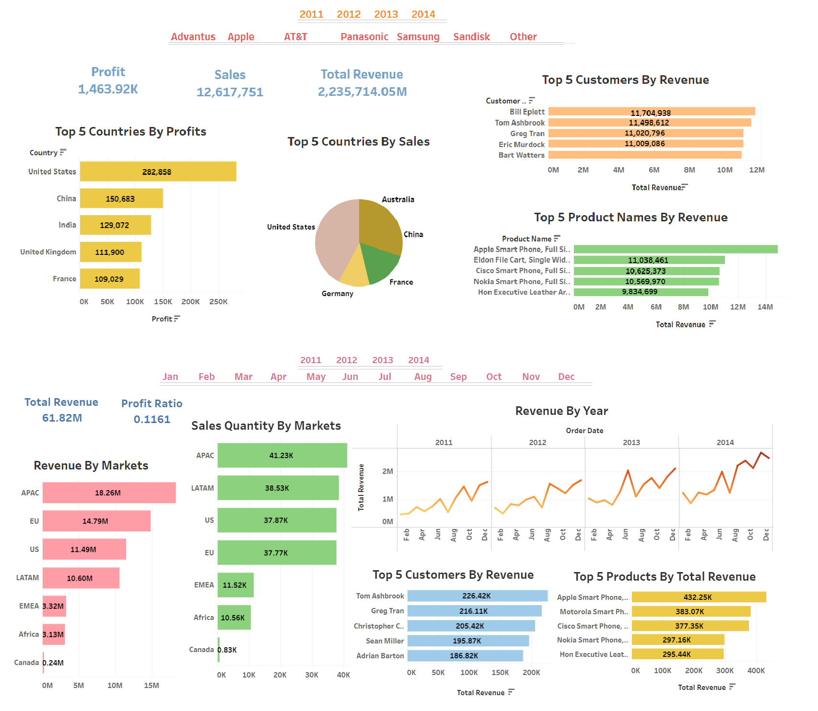

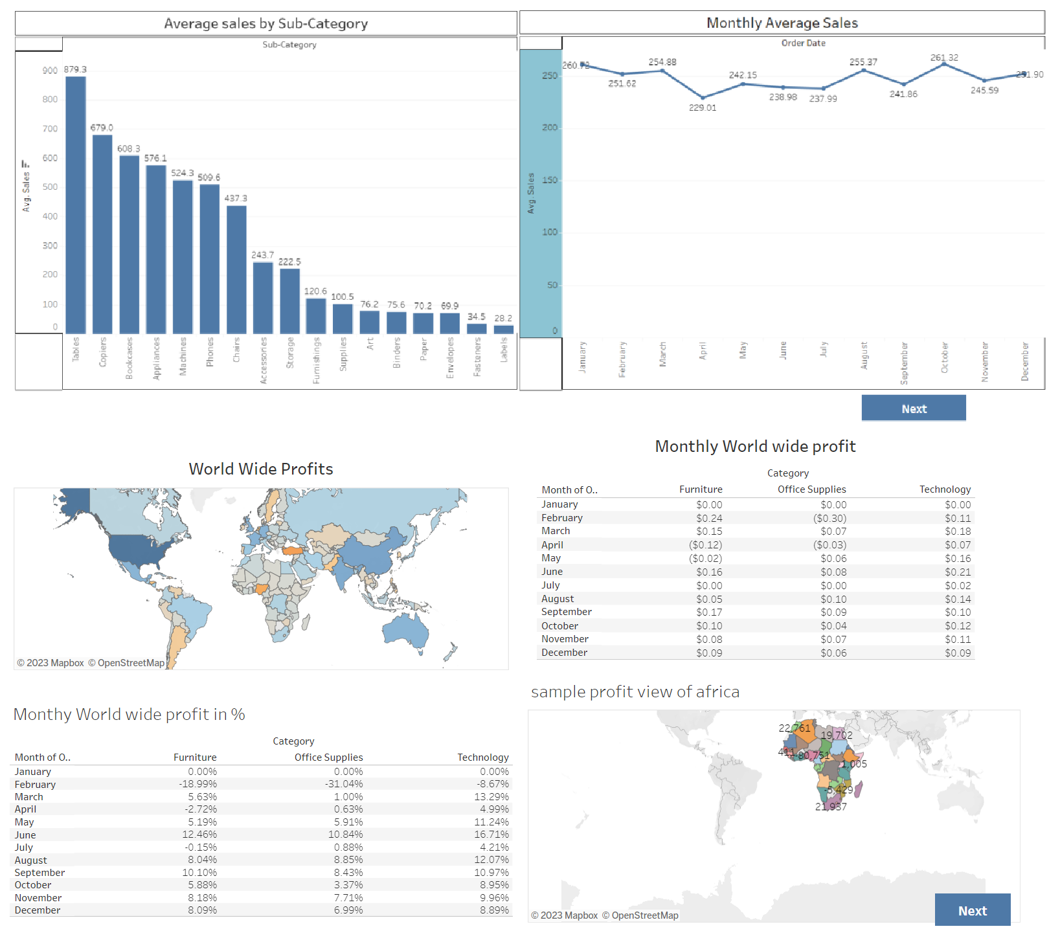

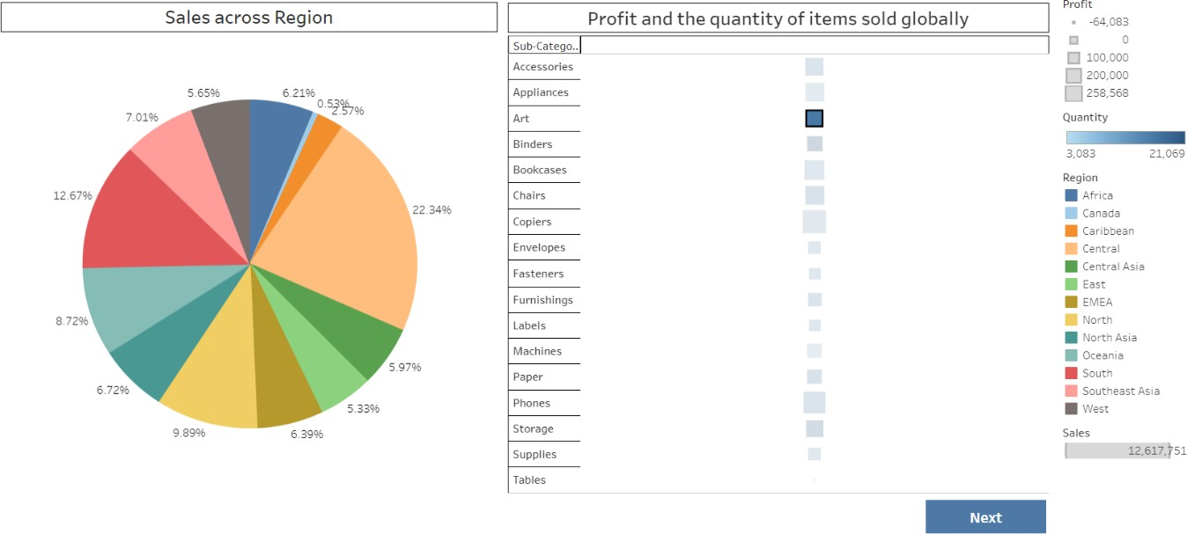

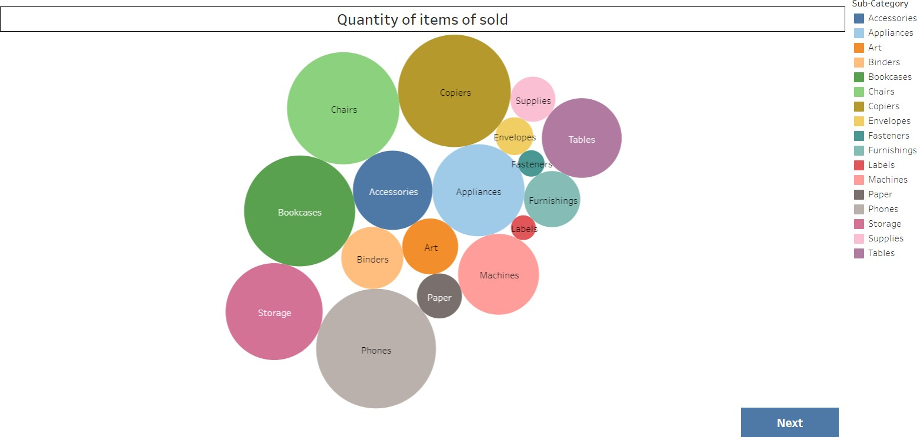

1. **ADVANTAGES AND DISADVANTAGES**

The solution of a Global Sales Data Analysis Project offers several advantages and disadvantages.

## Advantages:

* **Data-Driven Decision Making:** By analyzing global sales data, businesses can make informed, data-driven decisions. They can identify trends, patterns, and customer preferences, enabling them to optimize sales strategies.
* **Competitive Advantage:** Analyzing global sales data allows businesses to gain a competitive edge. They can identify market trends, consumer preferences, and customer behavior, which helps them tailor their offerings.
* **Forecasting and Planning:** Sales data analysis enables accurate sales forecasting and demand planning. This helps organizations optimize inventory levels, production schedules, and resource allocation.
* **Customer Insights:** This information helps businesses personalize marketing campaigns, improve customer experiences, and foster customer loyalty.

## Disadvantages:

* **Data Quality Challenges:** Poor data quality, missing values, or inconsistent data can hinder the accuracy and reliability of analysis results.
* **Complex Data Integration:** Global sales data analysis often involves integrating data from multiple sources and systems. Data integration can be complex.
* **Privacy and Security Risks:** Global sales data may contain sensitive customer information, such as personal details or financial data.. Data breaches or

mishandling of sensitive data can lead to reputational damage and legal consequences.

* **Expertise and Resource Requirements:** Conducting effective global sales data analysis requires expertise in data analytics, statistical modeling, and domain knowledge.

# APPLICATIONS

Global Sales Data Analysis has numerous applications across various industries. Here are some key applications:

* **Sales Performance Optimization:** Global sales data analysis helps businesses optimize their sales performance by identifying key growth areas, underperforming regions, products, or customer segments. It enables

organizations to refine their sales strategies, target the right markets, and allocate resources effectively.

* **Market Expansion and Penetration:** By analyzing global sales data, businesses can identify new market opportunities and make informed decisions regarding

market expansion. They can identify regions or countries with high growth potential, understand local market dynamics, and adapt their sales.

* **Customer Segmentation and Targeting:** Global sales data analysis allows organizations to segment their customer base based on various criteria such as demographics, behavior, or preferences. This segmentation helps tailor marketing efforts, personalize customer experiences.
* **Pricing and Revenue Optimization:** Analyzing global sales data helps organizations optimize pricing strategies and maximize revenue. By evaluating pricing elasticity, competitive pricing, and customer buying patterns.
* **Demand Forecasting and Inventory Management:** Global sales data analysis facilitates accurate demand forecasting, which is essential for effective inventory management. By understanding sales patterns, seasonal variations, and demand fluctuations, businesses can optimize their inventory levels, minimize stockouts, and reduce carrying costs.
* **Product Performance Analysis:** Global sales data analysis provides insights into the performance of individual products or product categories. Organizations can

identify top-selling products, assess product profitability, and make data-driven decisions regarding product development, marketing efforts, and portfolio optimization.

* **Competitor Analysis:** Analyzing global sales data allows businesses to gain

insights into competitor performance, market share, and pricing strategies. By understanding the competitive landscape, organizations can identify areas for differentiation, improve competitive positioning, and develop effective sales and marketing tactics.

* **Sales Forecasting and Planning:** Utilizing global sales data analysis, businesses can forecast future sales trends and plan their operations accordingly. Accurate

sales forecasting helps in budgeting, resource allocation, production planning, and overall business strategy.

* **Sales Team Performance Evaluation:** Global sales data analysis provides

insights into the performance of sales teams and individual sales representatives.

By analyzing sales metrics, organizations can evaluate performance, identify training needs, and implement incentive programs to drive sales productivity.

# CONCLUSION

After analyzing global sales data, several key conclusions can be drawn:

**Market Trends:** Global sales data analytics provides valuable insights into market trends. It helps identify patterns and preferences among consumers, allowing

businesses to adapt their strategies accordingly. By analyzing sales data, companies can understand which products or services are in high demand and make informed

decisions about their inventory and production.

**Customer Segmentation:** Sales data analytics enables businesses to segment their customers based on various criteria such as demographics, behavior, and purchasing patterns. This segmentation helps in creating targeted marketing campaigns and personalized experiences for different customer groups, leading to improved customer satisfaction and loyalty.

**Pricing Optimization:** Global sales data analytics can assist in determining optimal pricing strategies. By analyzing sales data, companies can identify price elasticity, demand fluctuations, and competitive pricing dynamics. This information helps in setting prices that maximize revenue and profitability while remaining competitive in the market.

**Inventory Management:** Accurate sales data analytics facilitates efficient inventory management. By analyzing sales patterns and demand forecasts, businesses can

optimize their inventory levels, reducing the risk of stockouts or excess inventory. This leads to cost savings, improved cash flow, and enhanced customer satisfaction through timely product availability.

**Sales Performance Evaluation:** Global sales data analytics allows companies to evaluate their sales performance on various levels. It enables the identification of top- performing products, regions, or sales teams, as well as areas of underperformance.

This information helps in identifying areas for improvement, setting realistic sales targets, and aligning resources effectively.

**Market Expansion Opportunities:** By analyzing sales data across different regions and markets, businesses can identify potential opportunities for market expansion.

Sales analytics can reveal untapped markets, emerging trends, or underserved customer segments, guiding strategic decisions for geographic expansion, product diversification, or targeted marketing efforts.

**Forecasting and Predictive Analytics:** Sales data analytics can provide valuable insights for forecasting future sales trends and predicting customer behavior. By

analyzing historical sales data combined with external factors like economic indicators or seasonal patterns, businesses can make accurate forecasts, plan production and resources accordingly, and optimize their overall operations.

# FUTURE SCOPE

Here are some key aspects that highlight the future scope of this project:

* **Big Data and Advanced Analytics:** As the volume, variety, and velocity of sales data continue to increase, there will be a greater emphasis on handling big data and leveraging advanced analytics techniques. This includes the use of machine

learning, artificial intelligence, natural language processing, and predictive modeling to uncover deeper insights and make more accurate sales forecasts.

* **Real-time Analytics:** Organizations will aim to extract insights and respond to changing market conditions and customer behaviors in real-time. This will enable businesses to make timely adjustments to their sales strategies, pricing, promotions, and inventory management.
* **Integration with IoT and Sensor Data:** The Internet of Things (IoT) and sensor technologies will provide additional sources of sales data. Integration of IoT data from connected devices, point-of-sale systems, and wearable devices will enable more comprehensive analysis and enable organizations to gain a better understanding of customer behavior and product usage.
* **Enhanced Customer Insights:** The future of global sales data analysis will focus on obtaining more granular and personalized customer insights.
* **Intelligent Sales Automation:** Automation and artificial intelligence will play a significant role in streamlining sales processes. Intelligent sales automation systems will leverage global sales data analysis to automate routine tasks, provide sales recommendations, and enable personalized interactions with customers.
* **Prescriptive Analytics:** The future scope of global sales data analysis will go beyond descriptive and predictive analytics to include prescriptive analytics. Prescriptive analytics will provide actionable recommendations.
* **Industry-Specific Applications:** Global sales data analysis will be increasingly tailored to industry-specific needs. Different sectors such as retail, e-commerce, manufacturing, healthcare, and finance will develop specialized approaches and metrics to address industry-specific challenges and leverage the full potential of sales data analysis within their domains.

# BIBILOGRAPHY

1. Predictive Analytics: The Power to Predict Who Will Click, Buy, Lie, or Die" by Eric Siegel
2. "Data-Driven: Creating a Data Culture" by Hilary Mason and DJ Patil
3. "Sales Analytics: A Practical Guide for Leveraging Big Data to Drive Sales" by Cesar Brea
4. towardsdatascience.com
5. stackoverflow.com